Communication expectations across different settings
Speech Pathology Australia has created this handout for the webinar ‘Communication expectations across different settings’. It supports you to identify communication expectations of a young person across different settings. We’ve included instructions to guide you through a case study and activities that align with the webinar.

Layer 1: Communication skills in everyday situations
This is Gemma’s story. While it is fictional, the many young people and families we have had the privilege of supporting inform it.
Gemma recently turned 20 and lives at home with her parents. Her sister, Hayley, works in human resources at a large city hospital and her brother is a motor mechanic.
Gemma has a part-time job at a bakery. She says she learns best when shown how to do something rather than people telling her. She is confident going by train to her job, and hopes to drive when she gets her P plates.
Gemma loves shopping for fashion and crafts in town or at the local mall, and meeting her friends for coffee or lunch. From a young age she has loved craft and spends hours on YouTube and Instagram looking for inspiration. She is thinking of joining a local craft meet up.
Gemma often babysits and loves spending time with toddlers and babies. She is kind and respectful with elderly people. She is a real softie and always willing to help in practical ways.
Gemma’s friends enjoy her company. They say she is happy and bubbly and often funny, usually unintentionally because she often takes things literally or misinterprets what people say. In new situations, Gemma usually lets her friends lead the way, and is more of a follower.
Gemma hates having to explain how to do something as she gets the order muddled. When giving directions, she gets tends to mix up right and left.
Gemma gets stressed when people use a bossy tone or when she feels co-workers at her part-time job are taking advantage of her or laughing at her. When something isn’t going right, Gemma says she goes quiet. She finds it hard to speak up for herself outside of her family.
Gemma’s speech has always been easy to understand, although she sometimes speaks too softly when anxious. Her mum, Julie, notices that Gemma can be hard to follow as she says ‘thing’ and ‘stuff’ a lot instead of specific words.
Julie notices Gemma has trouble grasping new ideas and following current events. This is becoming more obvious now Gemma is an adult and expected to take part in adult conversations. She often needs people to explain things a few times, go slower, and break it down into steps.
Gemma says reading has always been a struggle, and she would rather watch TV than pick up a book.

Complete ‘Activity: Layer 1 – communication skills in everyday situations’

Activity: Layer 1 – communication skills in everyday situations*
Gemma may not be able to do ALL aspects of a skill. Highlight what she can do. Underline what might be challenging.
- Start and end conversations with family, friends and others (e.g. shop assistants, co-workers, café staff)
- Use appropriate eye contact, gestures, body language and facial expressions
- Keep up with the pace of conversation, follow the topic and make appropriate and well-timed contributions
- Speak fluently, clearly and at the right volume for the situation
- Speak at the right pace so listeners can easily follow
- Choose words that suit the listener’s age and knowledge
- Use sentences with correct grammar and specific vocabulary (rather than ‘it’, ‘thing’, ‘stuff’)
- Use words such as because, if, so, when, since, whenever to join sentences
- Engage in small talk and banter with family, friends and others
- Get sarcasm, and understand expressions (e.g. ‘Rome wasn’t built in a day’)
- Share ideas, opinions and preferences using sentences that are easy to follow
- Explain things and give instructions in the right order, with enough detail
- Describe events and personal experiences that are interesting and make sense
- Follow and discuss current issues and trends on TV & streaming services, social media and magazines
- Understand explanations and follow detailed instructions
- Read and understand written instructions, articles and books
- Communicate via social media (including the phone)
- Speak up when unsure, and ask for help with family, friends and others
- Place orders (e.g. for food), ask for information and negotiate prices
- Clarify when misunderstood by family, friends and others
- Assert herself with friends and family, and in public (e.g. when returning/exchanging things)
- Negotiate with friends and others to resolve conflicts and differences of opinion
- Understand & use social media, text talk (e.g. FOMO, YOLO, awks), & visual communication (e.g. Emojis, gifs)
Return to the webinar
* The answers are at the end of this handout.

Layer 2: Additional communication skills for Specific Settings
TAFE: aged care course | Working at the bakery | Applying for a job
- Relate to students of different ages from diverse backgrounds  - Communicate with staff and students by email  - Understand timetables and deadlines  - Follow lectures  - Learn new terms and vocabulary and make links across subject areas  - Explain new concepts  - Use the internet and text books to research topics and take notes  - Synthesise ideas into own words  - Discuss ideas, share opinions and experiences  - Group work which may include leading, taking notes, making suggestions and negotiating  - Complete forms, quizzes, written assignments and verbal assessment tasks  - Document workplace or class activities  - Ask for and understand advice and feedback  - On placement, adapt communication style and content to people in aged care and their family, workplace colleagues and supervisors | - Use social communication skills (including banter) to get along well with customers, bakers and co-workers  - Use friendly greetings and body language  - Tune in to body language (e.g. is the customer in a hurry, still thinking or upset)  - Manage multiple people waiting  - Handle queries and fussy/complaining customers  - Understand products and customers’ needs  - Explain price increases and different products, and make recommendations  - Understand verbal and written material about products and procedures  - Ask for clarification about products, policies, procedures and money issues at right time  - Read and understand shifts and rosters; negotiate these as needed  - Use technology for staff communication  - Know when to ask for help and offer help  - Ask assertively about pay and rights  - Participate in OH&S procedures and practices | - Search the internet for vacancies  - Read and interpret ads and job descriptions  - Appreciate difference between agency, casual and permanent positions  - Think critically about the location and nature of the job  - Seek more information about things not explicitly stated  - Write a resume that includes achievements, personal qualities, experiences and goals  - Use words to promote oneself and demonstrate knowledge of the sector  - Write a cover letter  - Understand the words needed to present the values and culture of aged care so as to include that in application and interviews  - Fill in forms and apply online  - Use appropriate body language and facial expression in interview
Layer 3: Vocabulary used in Specific Settings
TAFE: aged care course | Working at the bakery | Applying for a job
- Private residences, nursing home  - Aged care home, facility  - Work autonomously  - Work collaboratively  - Cultural sensitivity  - Learning culture  - Continuous improvement  - Practice and promote self-care strategies  - Residents  - Standards of care  - Legislation  - Occupational health and safety (OH&S)  - Advocate  - Interpersonal communication skills  - Empathy, dignity, respect, compassion  - Monitor and record  - Boundaries  - Safety, choice | - PPE  - OH&S  - Words for the different breads  - Shift rosters  - Penalty rates  - Policy and procedures  - Upsell and cross-sell  - Promotion  - Combo sales  - Discounts  - Loyalties  - Food safety terms  - Names of cleanings products | - Job description  - Resume  - Curriculum vitae (CV)  - Key selection criteria  - Qualifications  - Referees  - Values and principles

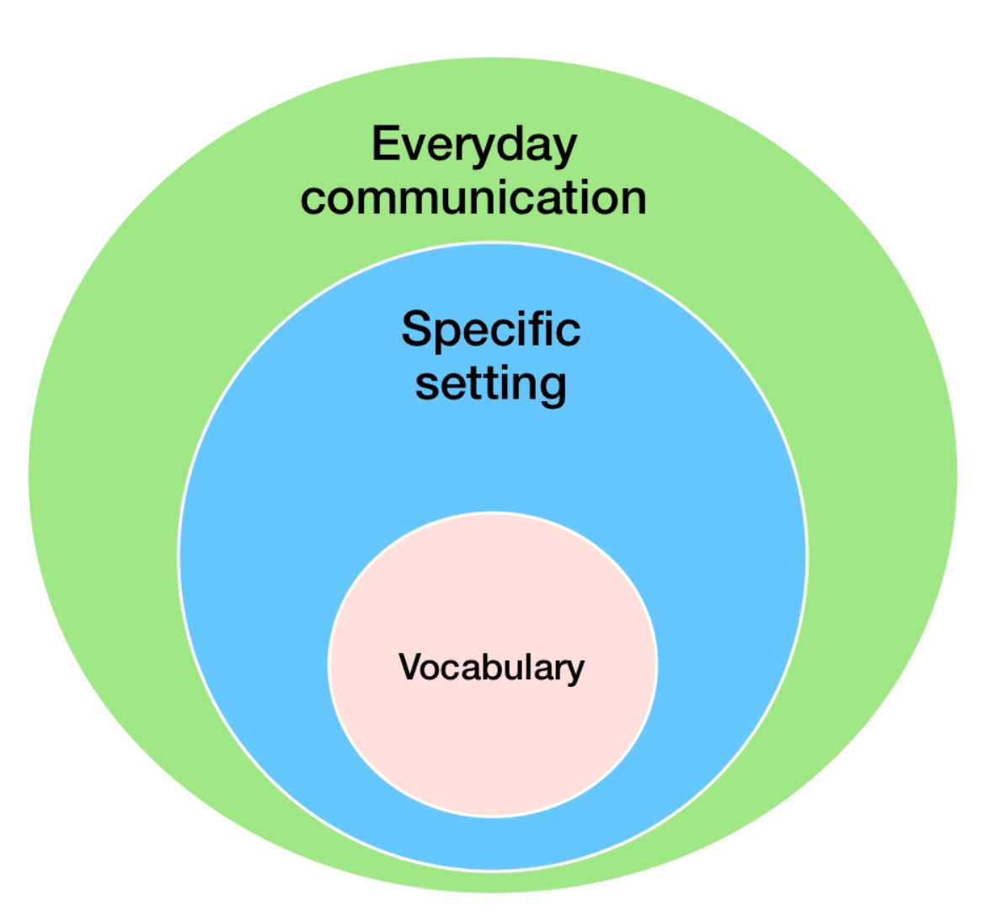
Layer 1  Everyday communication | These are the communication skills for everyday life when young people go on public transport, shop, talk with family, peers and others, use social media, eat out and do activities and hobbies.  Communication includes speaking & understanding, reading and writing.  Most young people develop these skills during childhood and fine-tune them in adolescence. This happens through supportive relationships, opportunities to observe others and encouragement to have a go. Support and guidance at school and during out of school activities helps develop these skills. | Young people can have difficulties at this level and need support.  If they have difficulties at Layer 1, then they will most probably have challenges in layer 2 settings  Some young people may have adequate language skills (i.e. vocabulary, grammar and understanding), and read and write well but have difficulties with the social part of communication.  If English is a new language, it can take several years to develop everyday communication skills.
Layer 2  Specific settings | Layer 2 settings require additional communication skills.  Settings include education (high school, TAFE, training, university), the workplace, youth justice, health, mental health, and drug and alcohol services etc.  Layer 2 also includes situations that are new for the young person, but familiar for many adults. Learning to drive and voting are examples.  This layer also includes rare situations e.g. providing a witness statement to the police. | Identifying the communication expectations of a setting is the first step to working out if a young person can participate easily without much help, OR needs adjustments made OR additional support, OR the help of a Speech Pathologist.  Breaking down new situations in to smaller tasks can help work out what the young person needs to do, and needs support to do.
Layer 3  Vocabulary | This layer is about the words used in a Specific Setting.  Vocabulary includes difficult words, technical terms and jargon. | These words are not used frequently in everyday conversation. Young people may not have heard these words before, or misunderstand them.  Vocabulary needs to be identified, explicitly taught and practiced.
What helps young people with communication needs?
Being communication Aware | - Learn how to recognise communication needs.  - This includes talking and understanding, reading and writing.  - Notice behaviours that might mask or hide any difficulties.
Being willing to  Adjust  the way you communicate | - Consider how much and how fast you talk, and the words you use.  - Is this a good match for the young person? If not, then adapt what you say. Use shorter sentences, pause more often and say less.  - Show patience, and allow more time for young people to take in what you say. This also gives time to request clarification.  - Replace difficult words with easy to understand words.  - Provide enough opportunities so the young person understands.  - Pictures, photos and diagrams can be helpful.  - Check with the young person what helps them.
Support the young person  to understand and  Accept  their communication needs,  and accept help | - Start a conversation about communication. Are they aware of their communication needs?  - How does the young person manage when confused or they don’t understand? Do they speak up to ask for help? When, who with, and how? Are they specific? What usually happens?  - Develop a shared understanding about communication needs  - Build self-awareness and self acceptance  - This will help the young person be able to ask for and accept help  - Support them to self-advocate  - Support them to find a ‘go to’ person they can trust. They may need you (or someone else) to advocate for them initially.
Work with them to  Accommodate  to their learning style | - Partner with them to work out what helps and what hinders them.  - How do they learn best? Does showing, repeating or practice help? Is hands-on learning easier for them?  - Are there conditions under which they communicate better?  - Support them to use their strengths to help them, e.g. being visual.  - Support them to see the links between communication and stress.  - Teach and foster the young person to speak up when confused or unsure, or when they don’t understand certain words.  - Encourage them to be specific in what they need from you.

Answers: Layer 1 – communication skills in everyday situations

We have bolded what Gemma can do.
We have underlined skills Gemma might find challenging in some contexts.

- Start and end conversations with family, friends and others (e.g. shop assistants, co-workers, café staff)
- Use appropriate eye contact, gestures, body language and facial expressions (when anxious Gemma finds it hard to look people in the eye)
- Keep up with the pace of conversation, follow the topic and make appropriate and well-timed contributions (Gemma manages best with very familiar topics about her interests)
- Speak fluently, clearly and at the right volume for the situation
- Speak at the right pace so listeners can easily follow
- Choose words that suit the listener’s age and knowledge
- Use sentences with correct grammar and specific vocabulary (rather than ‘it’, ‘thing’, ‘stuff’)
- Engage in small talk and banter with family, friends and others
- Get sarcasm, and understand expressions (e.g. ‘Rome wasn’t built in a day’)
- Share ideas, opinions and preferences using sentences that are easy to follow
- Explain things and give instructions in the right order with enough detail
- Describe events and personal experiences that are interesting and make sense
- Follow and discuss current issues and trends on TV & streaming services, social media and magazines
- Understand explanations and follow detailed instructions (Gemma has difficulty if explanations are longer than 5 sentences)
- Read and understand written instructions, articles and books
- Communicate via social media (including the phone)
- Speak up when unsure, and ask for help with family, friends and others
- Place orders (e.g. for food), ask for information and negotiate prices
- Clarify when misunderstood by family, friends and others
- Assert herself with friends and family and in public (e.g. when returning/exchanging things)
- Negotiate with friends and others to resolve conflicts and differences of opinion
- Understand & use social media, text talk (e.g. FOMO, YOLO, awks), & visual communication (e.g. Emojis, gifs)

Handout citation: Fleming M, Lim S. Communication expectations across different settings [webinar handout]. Speech Pathology Australia; handout provided for a webinar for Orygen, The National Centre of Excellence in Youth Mental Health, 2019 May.

The Tiers of Vocabulary developed by Beck, I. McKeown, M., & Kucan, L. (2002). Choosing Words to Teach. In Bringing Words to Life: Robust Vocabulary Instruction (15-30). New York, NY: Guilford Press inspired our Layers metaphor

